
A10
Sreenidhi Institute of Science & Technology
(An Autonomous Institution)
Code No: 101MA01/111MA01
B. TECH. I – Year I – Semester Examinations, January 2015 (Supplementary)
ENGINEERING MATHEMATICS –I (Common to All except BT)

Time: 3 Hours Max. Marks: 70

Note: No additional answer sheets will be provided.

Part - A
Max.Marks:20

Answer all QUESTIONS.
1. Prove that the matrix 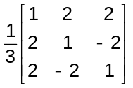 is orthogonal.
2. Find the eigen values of the matrix 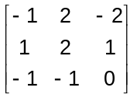
3. Evaluate 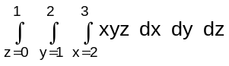.

4. Determine the nature of the series 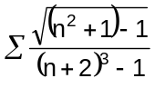
5. Verify Cauchy's mean value theorem for the functions e^{x} and e^{-x} in the interval (a,b).
6. Verify the continuity of the function 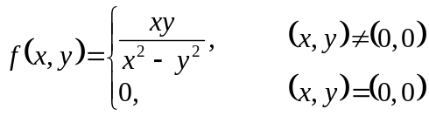

7. Discuss the maximum and minimum of the function 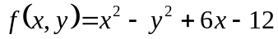

8. Find the radius of the curvature of the curve 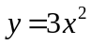at (1, 3)

9. Find the asymptotes of the curve 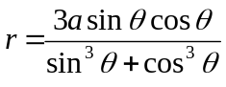

10. Evaluate by changing the order of the integration 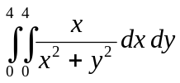

Part – B
Max.Marks:50
ANSWER ANY FIVE QUESTIONS. EACH QUESTION CARRIES 10 MARKS.
1. a) If A = 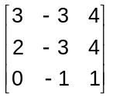, show that A³=A⁻¹.
b) Investigate the consistency of the following equations and if possible find the solutions.
4x-2y+6z=8; x+y-3z=-1; 15x-3y+9z=21

2. a) Find the characteristic equation of the matrix A = 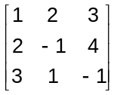 and hence verify Cayley - Hamilton theorem.
b) Using Cayley-Hamilton theorem find the inverse of 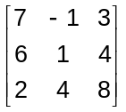.

3. Reduce the quadratic form 3x²+5y²+3z²-2yz+2xz-2xy to canonical form.

4. a) Test the convergence of the series
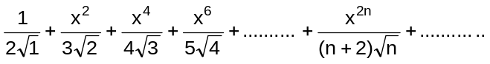.

b) If f(x)=sin⁻¹(x), 0<a<b<1, use mean value theorem to prove that 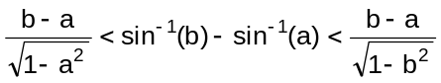.
5. a) If 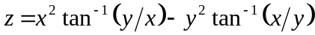, then find the value of 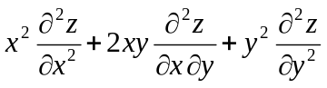

b) If x = uv, y = u/v, then prove that 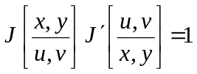

  - a) Show that the radius of curvature of at P on the ellipse 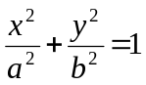is CD³/ab where CD is the semi diameter conjugate to CP.
- Show that the evaluate of the curve 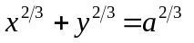is 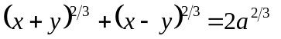

  - a) Trace the curve 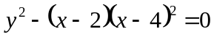
- Trace the curve given by 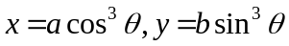

  - a) Find the total length of the curve 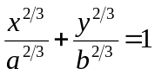
b) Evaluate 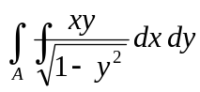, where A is the area in the positive quadrant of the circle 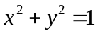
-- 00 -- 00 --

